**Criterion C – Development**

This application is programmed using Eclipse Neon, incorporating elements such as JFrame objects and Graphics classes.

The program operates on the idea that the MainMenu will contain a limitless number of selections to be made, each with its own unique production of a Graphics produced image. Therefore, the initial implementation of the main screen is just to allow RadioButtons to be placed on the screen and that each button clicked will be able to open up a Graphics Window.

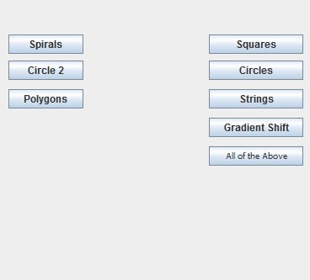

*Picture 1: MainMenu window.*

This therefore allows robust additions of further selections, as all that is required is a custom class that actually produces a Graphics image and then making sure a RadioButton allows to open up that class.

Each selection has a code upon being clicked that opens up a new Java file, or more specifically, opens up a Java class that produces a Graphics image.

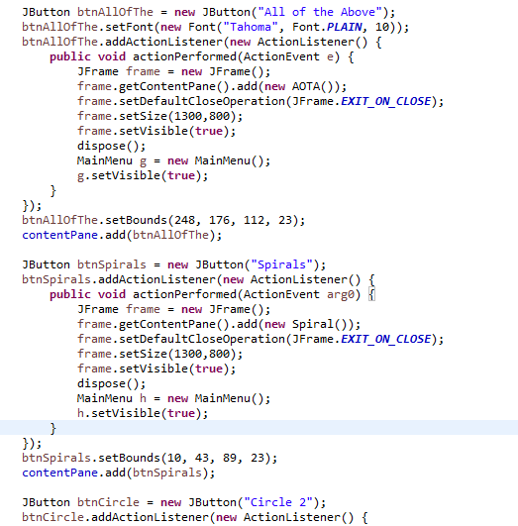

*Picture 2: Code to show how custom classes are opened.*

Each individual class has its own code that uses Random variables to provide a variety of different options that allow each Graphics window that is produced to be one amongst many different permutations. The idea is that the number of permutations should be large enough that the same exact Graphic shouldn’t be repeated. Nested for loops are used along with switch statements to provide the maximum randomness possible.

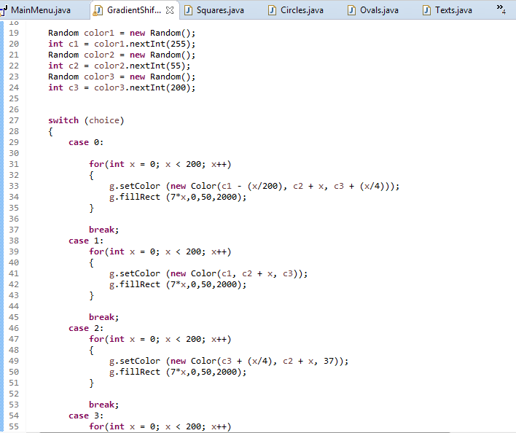

*Picture 3: Code that shows how colors and hues is randomized*.

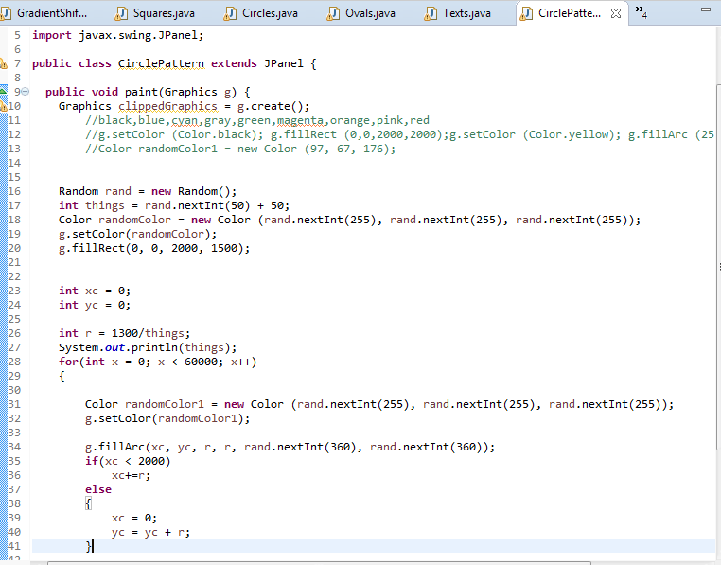

*Picture 4: Code that shows randomization of arc angles and placement.*

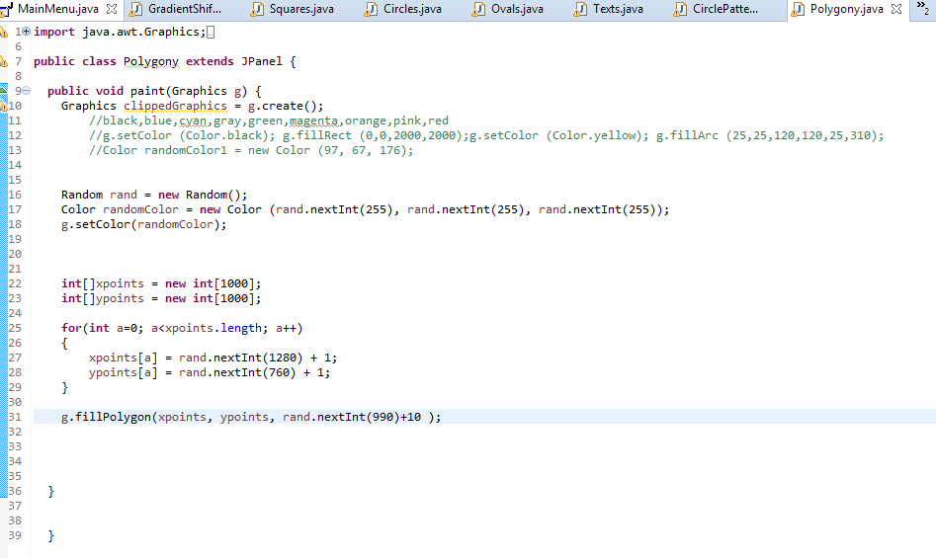

*Picture 5: Code that shows randomization of how many points and shapes are made.*

In the end, each option provides an array of aesthetically pleasing images. Randomization ensures that a variety of Graphics are created, enough to satisfy the conditions that people may inherently desire in their pictures.

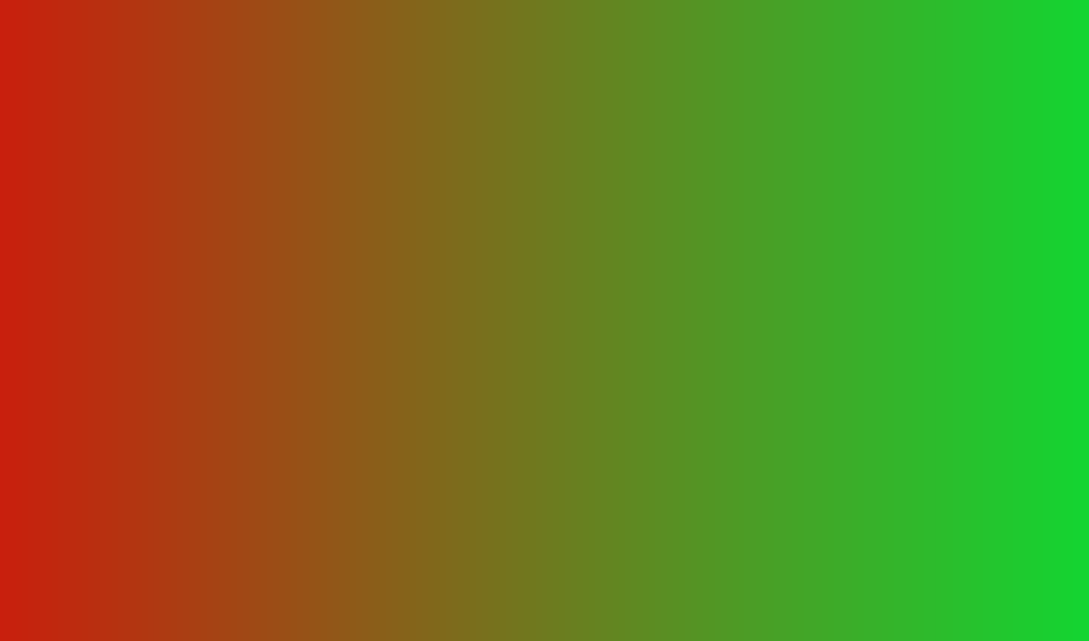

*Picture 6: Gradient shift that slowly changes the color of the very small rectangles made from left to right.*

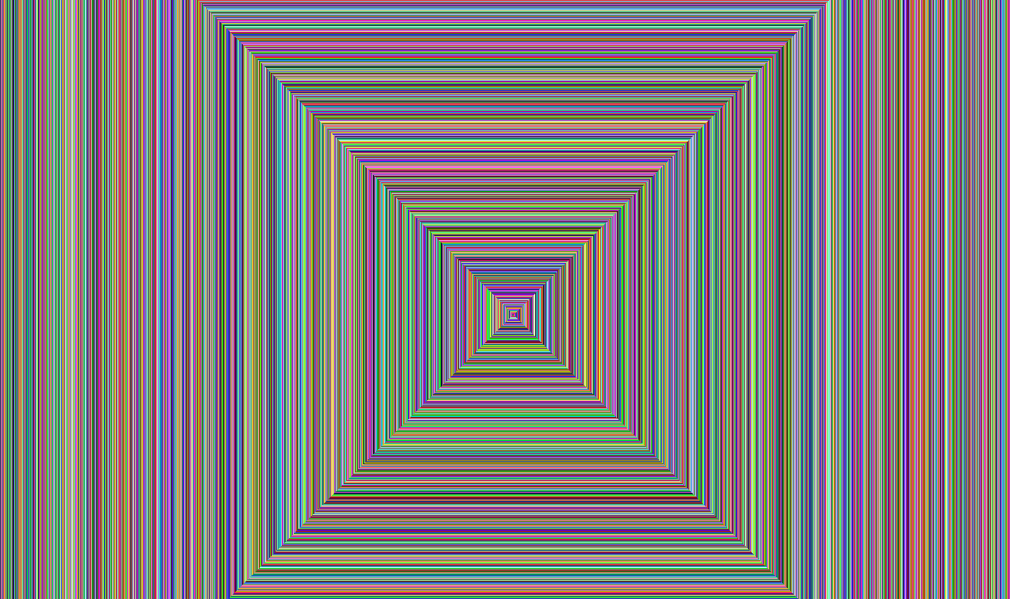

*Picture 7: Spiral that starts from coordinate point (600, 600) and follows a 1,1,2,2… pattern to make this hallway-looking spiral.*

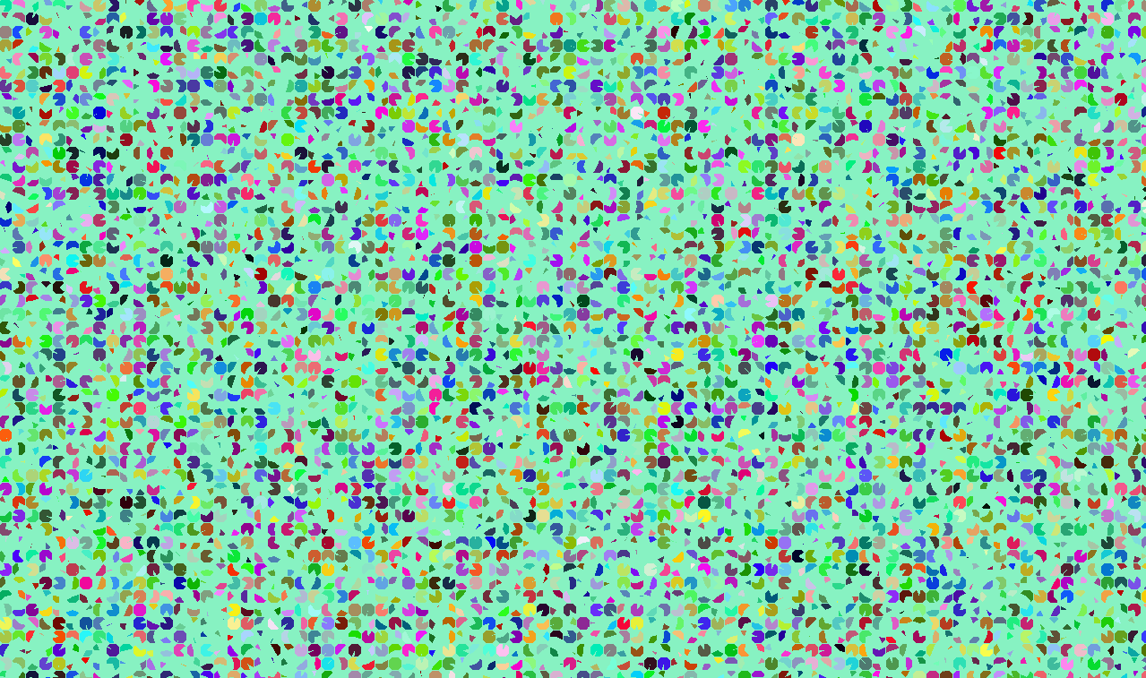

*Picture 8: Circle pattern that is randomzied for color, angles to which th arc is drawn, the background color, and the number of arcs made.*

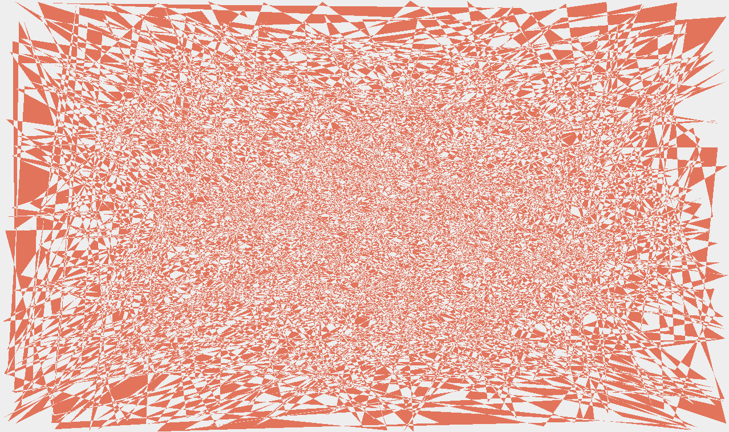

*Picture 9: Polygon creator that makes a random array of points, x and y, and draws them all in.*